Ahmed is practicing social distancing by doing shopping online. Ahmed has a number of items that he has to buy. You need to write a program to help Ahmed determine the minimum amount of money that he needs to spend to buy all the items?

Input is a file which has the following information:

The first line begins with a single integer, the number of test cases. Test cases follow. Each test case begins with one integer, the number of stores. Store descriptions follow. Each store description begins with an integer, the number of different items sold at each store.

The next lines each contain a lower-case string and two integers: the name of an item, its price, and the quantity that the store has in stock.

Each item's name will be unique, and contain at most 50 characters.

The next line contains an integer, the number of different items that Ahmed would like to buy.

The next lines each contain an item name and an integer, the amount of that item that Ahmed would like to buy. Each item's name will only appear at most once.

It is guaranteed that, unlike the real world, the total quantity of each item available in stores is greater than or equal to the quantity that Ahmed would like to buy.

Output:

For each test case, print a single integer: the minimum amount that Ahmed needs to spend to buy all the items that he wants.

Sample Input

1 //number of test cases

2 //number of stores

2 //number of items sold at store1

toiletpaper 1 50 //item name, its price, quantity in the stock

catnip 2 25 //item name, its price, quantity in the stock

1 //number of items sold at store2

toiletpaper 100 1 //item name, its price, quantity in the stock

2 //number of different items that Ahmed would like to buy

toiletpaper 51 //item name, the amount that Ahmed would like to buy

catnip 10 //item name, the amount that Ahmed would like to buy

Sample Output

170 // the minimum amount that Ahmed needs to buy all the items

Attached with this file, find two files “data.in” and “data.out”. Your program should take data.in file as input and if your code is correct it will produce exactly the same output as given in data.out file.

What you need to do is to create linked lists to solve this problem. For example, for the above data, your linked list should look like the following:

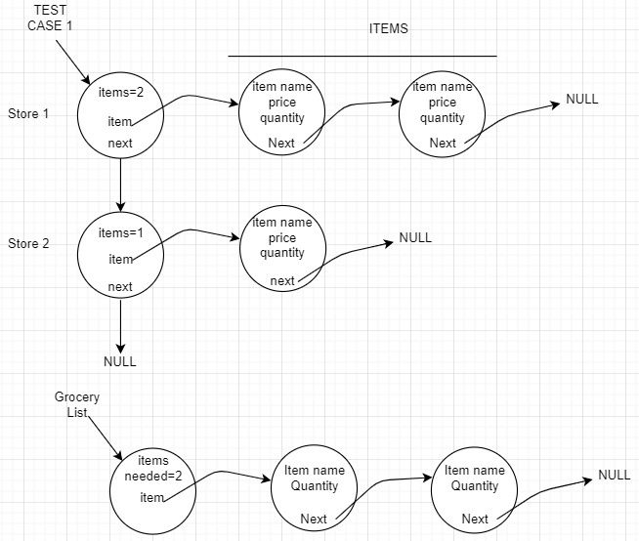

As you can see from the above figure, that you need to create two classes:

Class Item { String name, double price, int quantity, Item next }

Class Store { int itemCount, Item first, Store next }

Now the linked list will represent each test case like this:

Class TestCase { Store head } //this will be the linked list of all the stores in a test case.

You also need to create a class for grocery items as follows:

Class GroceryItem { String name, int quantity, GroceryItem next }

Now the linked list will represent grocery list as follow:

Class GroceryList { int itemsNeeded, GroceryItem head } //this is the linked list of all the needed items.